
Responsible Data Analytics
MSc
BI, Analytics, Sustainability & Ethics
(LNDN5203)

Assessment 1 - Dashboard Design and Analysis

Student full name: LAXMI BHALALA Student ID: P2942610 Word count : 500 to 550

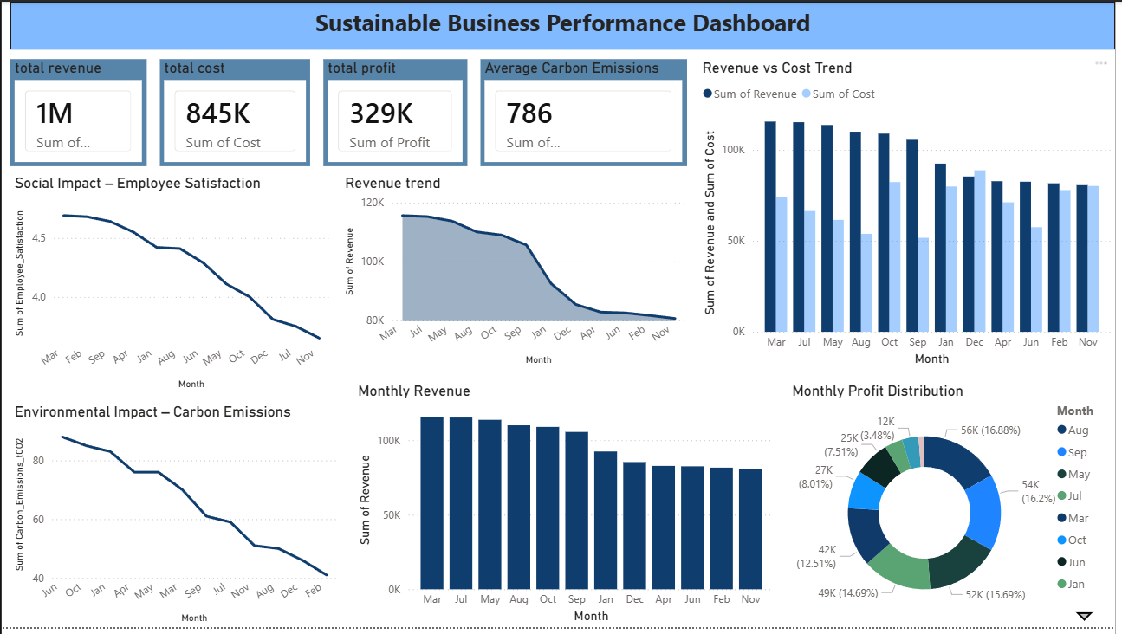

Introduction

Business Intelligence dashboards are widely used by organisations to transform raw data into meaningful insights that support decision-making. The dashboard developed for this assessment focuses on visualising key business performance indicators related to financial results, employee wellbeing, and environmental impact. By presenting information in a clear and interactive way, the dashboard helps managers quickly understand organisational performance and identify areas that require improvement. The dashboard includes KPI cards, trend charts, bar charts, and a profit distribution chart, allowing users to analyse business performance from multiple perspectives.

- Decision Support Framework

Selected Management Level: Tactical

The dashboard is designed to support tactical level managers who are responsible for monitoring departmental performance and implementing organisational plans. It presents key indicators such as revenue, cost, profit, employee satisfaction, and carbon emissions in a visual format, making it easier to understand performance trends. By reviewing these metrics across different months, managers can quickly identify areas that require improvement and make informed operational decisions.

- Sustainability Metrics – Triple Bottom Line

The dashboard is designed using the Triple Bottom Line (TBL) framework, which focuses on three key areas of sustainability: profit, people, and planet. This framework helps organisations evaluate their overall performance by considering not only financial results but also social and environmental impacts. By including indicators related to these three dimensions, the dashboard provides a balanced view of organisational performance and encourages responsible decision-making.

Profit (Economic):
Financial performance is shown through revenue, cost, and profit using KPI cards and charts to highlight business performance.

People (Social):
Employee satisfaction is displayed through a trend chart, helping managers monitor employee wellbeing.

Planet (Environmental):
Carbon emissions data is shown in a chart to track environmental impact and support sustainable practices.

- Ethical Data Governance

Ethical data governance refers to the responsible and secure management of organisational data. It ensures that data used for analysis is accurate, trustworthy, and handled in a transparent way. When developing the dashboard, several governance principles were considered to ensure that the information presented is reliable and supports ethical decision-making. Maintaining data quality and protecting sensitive information are important factors that help organisations use data responsibly.

Data Privacy:
Data privacy is protected by avoiding the display of personal or confidential information within the dashboard. Instead of presenting individual employee records, the data is shown in a summarised or aggregated format, such as overall employee satisfaction levels. This method allows managers to review general performance trends while ensuring that personal details remain confidential and protected.

Data Security:
Another key element of ethical data governance is data security. Access to the dashboard should only be provided to authorised personnel to prevent unauthorised viewing or modification of business data. Furthermore, organisational data should be stored in secure systems that include authentication and protection mechanisms. These security measures help minimise risks such as data breaches, unauthorised access, or misuse of sensitive information.

- UN Sustainable Development Goals Alignment

The dashboard also supports organisations in aligning their activities with international sustainability goals introduced by the United Nations. These goals encourage businesses to operate in a responsible way while considering economic growth, social wellbeing, and environmental protection. By displaying sustainability-related indicators, the dashboard allows managers to observe organisational performance and make decisions that support long-term sustainable development. Visual representations of these metrics make it easier to understand how business activities influence broader sustainability objectives.

References:

Elkington, J. (1997) Cannibals with Forks: The Triple Bottom Line of 21st Century Business. Oxford: Capstone Publishing.

Davenport, T.H. and Harris, J.G. (2007) Competing on Analytics: The New Science of Winning. Boston: Harvard Business School Press.

Few, S. (2013) Information Dashboard Design: Displaying Data for At-a-Glance Monitoring. 2nd edn. Burlingame: Analytics Press.

Kimball, R. and Ross, M. (2013) The Data Warehouse Toolkit: The Definitive Guide to Dimensional Modeling. 3rd edn. New York: John Wiley & Sons.

United Nations (2015) Transforming our world: The 2030 agenda for sustainable development. Available at: https://sdgs.un.org (Accessed: 17 March 2026).

Data Governance Institute (2014) Data Governance Framework. Available at: https://datagovernance.com (Accessed: 17 March 2026).

World Economic Forum (2020) The Global Risks Report 2020. Geneva: World Economic Forum.

